**MSHP Home Health Care Referral Workflow**

**Effective May 2025**

1. Providers will continue placing home health care referrals via Epic order ***9079: Amb Ref to Visiting Nurse Service.***
2. The MSHP Home Health Care team will review the referral and determine patient eligibility.
   * **Eligible patients**: The team will coordinate home health care services and keep the provider informed as usual.
   * **Ineligible patients**:

* The team will forward the referral to a home care agency and route a note to the ordering provider to inform them of the forwarded referral. All subsequent communication (acceptance, denial, or additional documentation requests) will be sent directly to your practice via the call center by the home care agency.
* **If the referral is declined by the home care agency because the patient is ineligible for home care, the patient only needs home health aide services, or due to copay concerns or lack of caregiver support**:
  + There is a high likelihood that other agencies may also deny the case.
  + In such situations, the provider should discuss and explore alternate care options directly with the patient.
* **If the referral is declined by the home care agency due to staffing constraints:**
  + The practice should directly refer to an alternate agency (see below) by sending the following via **secure, encrypted email**: Demographics, insurance, home care order, last progress note and Face-to-Face certification letter (available under the ‘Communications’ tab in Epic, see page 2).
  + Each practice will create their own workflow for this step.

**DiRECT AGENCY CONTACT INFORMATON For Practice staff**

Certified Home Health Agencies (CHHAs) provide RN, PT, OT, Speech Therapy and short-term home health aide services.

|  |  |  |  |  |
| --- | --- | --- | --- | --- |
| **ArchCare at Home** | **Constellation**  **Home Care** | **VNS Health** | **Mount Sinai at Home**  **Nassau & Queens only** |  |
| noconnor@archcare.org  [nvaldes@archcare.org](mailto:nvaldes@archcare.org)  [asiniscalchi@archcare.org](mailto:asiniscalchi@archcare.org) | [chs-referrals-ny@constellationhs.com](mailto:chs-referrals-ny@constellationhs.com) | Mamadou.Gueye2@vnsny.org  [Katrina.Misanina@vnsny.org](mailto:Katrina.Misanina@vnsny.org)  Gloria.Difeo@vnsny.org  [Michelle.Broitman@vnsny.org](mailto:Michelle.Broitman@vnsny.org)  [Rita.Kofmanlitvak@vnshealth.org](mailto:Rita.Kofmanlitvak@vnshealth.org) | [rose.hernandez@mountsinaihome.com](mailto:rose.hernandez@mountsinaihome.com)  [suzie.kennedy@amedisys.com](mailto:suzie.kennedy@amedisys.com)  [mark.berger@amedisys.com](mailto:mark.berger@amedisys.com) |  |

**CREATING a HOME HEalth face-to-face encounter certification letter**

**Step 1:** Open the patient’s chart and start a new **encounter note** or **visit note.**

**Step 2:** From the top panel, click on the **‘Communications’** tab.

**Step 3:** Click on **‘New Patient Letter’** to begin creating the letter.

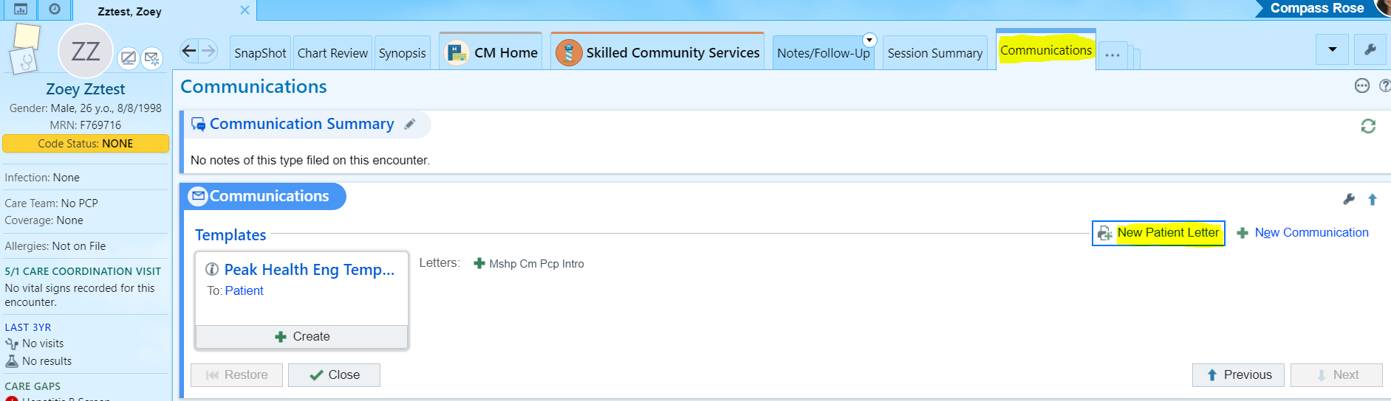

**Step 4:** In the search bar, type **‘Home Health’**. A list of options will appear. Select the **first option ‘Home Health Face-to-Face Encounter Certification’** and click **‘Accept’** to proceed.

**Step 5:** Complete the letter by editing all fields highlighted in **pink** and **blue**.

* For fields with a dropdown menu, you may either select from the available options or enter free text.
* For fields highlighted in blue, ensure that appropriate information is manually entered as needed.

**Step 6:** After completing the letter:

* Click **‘Pend’** to send it to the referring provider for review and signature within Epic, **OR**
* Click **‘Print Now’** to generate a physical copy that can be provided to the referring provider for their review and signature.
* Either option is acceptable.

**Step 7:** A copy of the completed letter will be saved under the **‘Communications’** tab in the patient’s chart for future reference.