Call4Health

**Resident Set Up:**

In order to cover night call, residents will need to have downloaded and set up a MiSecure account before the start of their shift as below. The PDFs at the bottom of this page show the download and set up instructions.

* Download the "C4HSecure" app on your phone
* Upon opening the app, it will ask for your username and password.
  + The normal username format is firstname.lastname
  + You can also enter your phone number into the username field
* Enter only your username, and then hit “Forgot/reset password”
* You will be sent a verification code to your phone. After inputting this, you will be prompted to reset your password

*If you have any issues logging in, see troubleshooting below.*

To be alerted of a patient call:

* In settings: make sure your notifications are on, select an interval for notification reminders, select a notification sound, and enter your callback number (callback number will be masked from the patient)
* In settings: go to “Session Timeout” and make sure “Push Notification” is turned on. This ensures that you will still get notifications even if the session “auto logs out”.
* Residents will receive a notification via the app when a patient calls in, so make sure that app notifications are on (instructions in attached PDF).
* If the app team doesn't see that they have read the notification alert, they will follow it up by calling the resident to alert them of the notification.

**Troubleshooting set up re account questions, updates, password resets:**

* Please email [oncall@call4health.com](mailto:oncall@call4health.com), include that you are a provider at Mount Sinai and the account number is 16911030vb.

**Troubleshooting when on-call**

* Call the call forwarding number is 646-517-3101 and press 9 and ask to speak to a supervisor
* You can also email the team 24/7 at Mt Sinai AH Admin: mtsinaiafterhoursadmin@call4health.com for immediate assistance
* Be ready to provide the account number for IMA: 16911030vb

1. **For providing updates to call schedule**: EMAIL ANETA AND ALAN GODOY who will email [oncall@call4health.com](mailto:oncall@call4health.com) to make changes
   1. The live excel document is shared with the Call4Health team, though they will not be able to track changes made to dates they have already entered
   2. Provide Account number when emailing: 16911030vb

The application you will need to download is called “C4H Secure” and will look like the icon below:

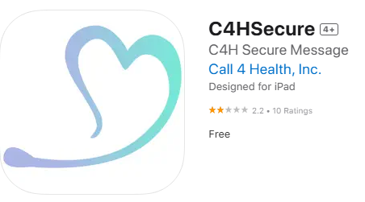

**Information Sheets:**

[Call4Health iOS: How To](https://drive.google.com/open?id=1u5HYs4eFEfrTFc050VsEbPFTB2uRG_32)

[Call4Health Android: How To](https://drive.google.com/open?id=1KJK_2Wd1b3qIKO3SANPKGU4zsjYeBqc6)

[How to Forward](https://drive.google.com/open?id=19Rpj8m560xlT-ebdaciZi5Km69fihyxI)

[Comprehensive App Guide](https://drive.google.com/open?id=1p6twZybkxQ-v8FhmVHW_n9vpdAsNKuaV)