2. Diabetes By Hannah Levavi

Overview:
(a) Who to screen: obese adults 40-70 years old
- USPSTF: Adults 40-70yo with BMI > 25. Screen Q3 years.
- ADA: All adults with BMI > 25 and ≥ 1 risk factor OR those > 45yo. Screen Q3 years.

(b) Screening Tests:
 | Diabetes | Pre-Diabetes
Hemoglobin A1C | >6.5% | 5.7-6.4%
Fasting Plasma Glucose | > 126 | > 100-125
Random Plasma Glucose | >200 and symptomatic
OGTT | >200 after 2 hours

- Need to confirm any positive tests!
- Can repeat every 1-2 years unless significant changes in risk factors or concerning symptoms.

(c) Type I DM Testing (patients with LADA—Latent Autoimmune Diabetes of Adulthood—will also have +Abs)
- Anti-islet cell antibodies
- GAD-65 (Glutamine Decarboxylase) antibodies

(d) Routine Care for Diabetic Patients:
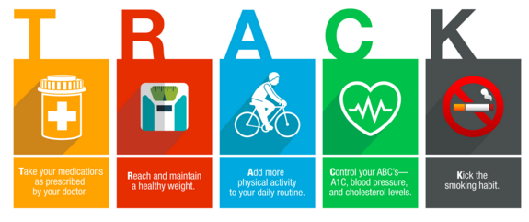
- Eye Examination (annual)
- Foot Examination (every visit)
- Nephropathy Screening (Microalbumin/Cr ratio)—need ≥ 2 positive tests
  - Screen starting at diagnosis for T2DM
  - Start screening 5 yrs after diagnosis for T1DM
  - If microalbuminuria is seen on ≥2 screenings, start ACEi
- Dietary/Lifestyle Counseling
- Smoking Cessation Counseling
- ? ASA Therapy—controversial whether ASA is indicated in primary prevention
- Statin Therapy in diabetes (USPSTF 2016):
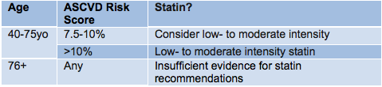

(e) A1c Goals:
- Most patients: ≤ 7
- Elderly patients: <8

(f) Initial Medical Management of DM:
- Unless there is a contraindication, all patients with T2DM should be on metformin

Drug Class | Examples | A1c Reduction |  | Side Effects | Comments | Healthfirst Medicaid | Fidelis Medicaid | Healthfirst Medicare
Biguanides | Metformin  Metformin ER | 1-2% | GI distress. Lactic Acidosis (rare but can be seen in those with CKD). |  | Weight neutral. No hypoglycemia. Okay to use in stable CHF. | Metformin  Metformin ER | Metformin  Metformin-ER | Metformin  Metformin ER
Sulfonylureas | Glipizide  Glipizide XL  Glyburide  Glimperide | 1-2% | HYPOGLYCEMIA |  | Efficacy wanes over time. | Glipizide  Glipizide XL  Glimepiride | Glipizide  Glipizide XL  Glyburide  Glimepiride | Glipizide  Glipizide XL  Glimepiride
Meglitinides | Repaglinide (Prandin)  Nateglinide (Starlix) | 1-2% | HYPOGLYCEMIA |  | Short-acting. Prandin is cleared via liver (so can use in CKD) | Repaglinide  Nateglinide | Nateglinide | Repaglinide  Nateglinide
Thiazolidinediones (TZDs) | Rosiglitazone (Avanda)  Pioglitazone (Actos) | 1% | Increased incidence of HF (Avandia), increases LDL, hypoglycemia, weight gain, osteoporosis, Bladder cancer (Actos) |  |  | Pioglitazone | Pioglitazone | Pioglitazone
Alpha Glucosidase Inhibitors | Acarbose | 0.5% | Flatulence, diarrhea, and abdominal discomfort are all common |  |  | Acarbose | Acarbose | Acarbose
SGLT-2 Inhibitors | Canagliflozin (Invokana)  Empagliflozin (Jardiance)  Dapagliflozin (Farxiga) | 0.5-1% | Polyuria, Increased UTIs, increased genital infections, hyperkalemia; increased risk of amputations (black box warning) |  | Improves CV outcomes (EMPA-REG OUTCOME Trial) | Canagliflozin (ST)  Empagliflozin (ST) | Canagliflozin (ST) | Dapagliflozin  Canagliflozin
DPP-4 Inhibitors | Sitagliptan (Januvia) Saxagliptan  Linagliptan (Tradjenta) | 0.5% | Headaches, GI upset. Slight increase in risk of URIs. ? Risk of arthralgias |  | No CV benefit. No definitive link to pancreatitis. | Linagliptan  Sitagliptan | Sitagliptan (ST) | Sitagliptan  Linagliptan
GLP-1 Agonists | Exenatide (Byetta) Exenatide XR (Bydureon)  Liraglutide (Victoza)  Dulaglutide (Trulicity)  Albiglutide (Tanezum) | ~ 1.0% | Injection site reactions. ? Risk of pancreatitis, medullary thyroid cancer. Nausea/Vomiting common. |  | Associated with weight loss (~3kg on average). No risk of hypoglycemia. Improves CV outcomes (LEADER Trial) | Albiglutide (ST)  Exenatide XR (ST)  Liraglutide (ST) | Albiglutide (ST)  Liraglutide (ST) | Dulaglutide  Liraglutide
Combo Pills |  |  |  |  |  | Glip-met  Lina-met  Pio-met | Glip-met  Lina-met  Pio-met | Janu-met  Glip-met  Cana-met

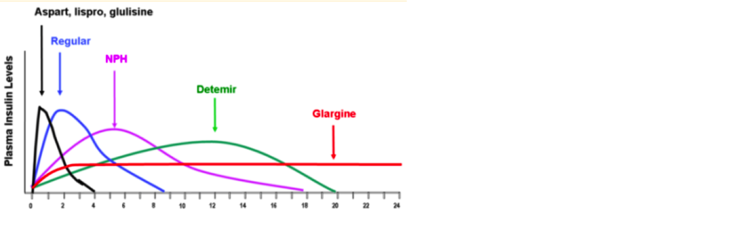
(g) Starting Insulin:
- Who to start on insulin:
  - A1c >10% at diagnosis
  - A1c >9% and already on metformin
  - A1c >8-8.5% and already on metformin + sulfonylurea
- Steps to Starting Insulin
  - Step 1: Start Basal Insulin
    - 0.2-0.3 units/kg/day; minimum of 10U to start
    - Glargine in AM or PM; Determir only in PM
    - Decrease if renal dysfunction, elderly, or insulin naïve
  - Step 2: Titrate Basal Insulin to good fasting control
    - Goal 70-130 fasting in AM
    - Patient can increase insulin by 2-3U every 3 days as long as FSG is above goal
  - Step 3: Start checking FSG pre-lunch, pre-dinner, and bedtime.
    - If control inadequate, start prandial insulin or adjuncts.
  - Step 4 (If needed): Start Prandial insulin with 4-6 units and titrate to good pre-meal control
    - Goal pre-meal FSG 70-130
    - Increase by 2U q3 days until adequate control achieved
    - If pre-lunch FSG is high: Adjust AM prandial insulin
    - If pre-dinner FSG is high: Adjust lunch-time prandial insulin
    - If bed-time FSG is high: Adjust dinner-time prandial insulin
  - Step 5: Assess need for further titrations, other adjuncts

Treating Diabetes at IMA:
- Order: “hemoglobin A1C”
  - For patients in whom you highly suspect a new diagnosis of diabetes or who are coming in for routine diabetes care and whose management would be changed by an A1c during the visit, order the “Hemoglobin A1c (POCT)” before you leave the room to precept. Inform the MA of the order so that the point of care test can be run as you precept and be done by the time you go back to see the patient.
  - In other patients who are getting screened but with only a few risk factors, or whose management in that visit may not change significantly with a rapid A1c, order the regular “Hemoglobin A1c.”

- Diabetic Foot Exam:
  - Inspect for skin integrity, calluses, gait, balance
  - Palpate pulses, ask about claudication
  - Test sensation using monofilament + vibration v. pinprick v. proprioception

- Eye Exam:
  - IMA Retinal Camera
    - Order: “OPH1120” and notify the MA
  - Fromer’s
    - Order: “consult to ophthalmology” and use “.fromer” dot phrase in the AVS for the locations and phone numbers
    - The front desk at IMA can now schedule Fromer eye appointments!
- Who needs referrals?
 | Intervention | How to Do It
A1c >12%  DM1  Pregnant women | Refer to Hospital Diabetes Clinic | Epic referral to “Hospital Diabetes Clinic”  Can call the clinic to make appointment
A1c 8 - 12% | Diabetes Educator | Order “consult to IMA Diabetes Educator”
 | City Health Works | Fill out form in referral box in each team room
 | PCP f/u Q 2-3 months
A1c 5.7 – 6.4% | YMCA Diabetes Prevention Program | Use “.diabetesprevention” in AVS  Fax a copy of the form
 | Nutrition consult | Order “Consult to Nutrition” in Epic

Social determinants of health:
- Individuals with lower income and education are 2-4 times more likely to get T2DM
- The physical environment in low-income areas often is not conducive to outdoor exercise (sidewalks in disrepair, lack of neighborhood safety)
- Food insecurity and food deserts may be correlated with worse outcomes in diabetes

Community Resources:
- City Health Works
  - Health coaches for patients in eligible zip codes
  - Consider for patients with low health literacy, those who do not keep appointment, or frequently run out of medications, those who utilize the ER for ambulatory sensitive needs, or get lost to follow-up easily.
- YMCA Diabetes Prevention Program
  - For patients with pre-DM to work on diet and exercise in a group setting.
- Screen patients for food insecurity using tool in Epic under rooming
  - If positive, refer to SW
  - For more fresh and healthy food options, some farmer’s markets accept SNAP/food stamps
  - Use “.foodresources” or “.food[borough” for pantry resources or find a list of nearby locations: https://nyccah.org/hungermaps
  - Let your patient know about an on-going study to get access to healthier foods and then email the principal investigator Dr. Mayer (Victoria.mayer@mountsinai.org)
- For women with diabetes, inform them of the exercise intervention on going at IMA

Population health/systems-based practice:
- Make sure to satisfy the BPAs for eye exams, nephropathy screening and foot exams in the Health Maintenance tab

