22. Dizziness by Rui Jiang

Overview:
Common Causes of dizziness (adapted from Table 1 of Molnar and McGee)
Causes | Emergency room (n=907) (%) | Primary care, elderly (n=1708) (%) | Specialized dizziness clinic (n=125) (%)
Peripheral Vestibular Disease * | 32 | 40 | 38
Orthostatic syndrome | 15 | 10 | --
Multiple sensory deficits ** | -- | 8 | 13
Psychiatric | 2 | 6 | 9
Infection | 4 | 4 | --
Central Neurologic (serious) | 5 | 4 | 5
Drug – related | 5 | 3 | --
Cardiac (serious) | 4 | 2 | 4
Unknown | 22 | 16 | 9
*Peripheral vestibular disease includes benign positional vertigo, vestibular neuronitis, Meniere disease.
**Multi-sensory deficits is most common in the elderly. Commonly includes decreased vision, vestibular disease, peripheral neuropathy, poor perfusion of the brain, and orthopedic disorders.

Pathophysiology:
- Benign positional vertigo:
  - Caused by abnormal movement of endolymph due to detached otoliths that settles in the most dependent portion of the inner ear, usually the posterior semicircular canal.
- Meniere disease:
  - Poorly understood pathophysiology
  - Most commonly thought to be due to increased endolymph pressure, leading to breaks in the intralabyrinthine membranes, and subsequently vertigo.
- Vestibular neuronitis (also known as viral neuronitis, acute vestibulopathy, epidemic vertigo, and acute labyrinthitis)
  - Caused by spontaneous mononeuropathy of the vestibular division of the eighth cranial nerve on one side. Mostly thought to be virally mediated.

Clinical findings (adapted from Table 2 of Moinar and McGee)
Questions | Purpose | Answers: suggested diagnoses
What do you mean by “dizzy?” | Further elicit historical points without prejudicing a particular diagnosis | Vertigo, light-headedness, disequilibrium
What brings on the dizziness? | Ascertain the type | Turning my head: vertigo  Rolling over in bed: vertigo  Standing up: presyncope  Stress: psychiatric  Walking: disequilibrium or multiple sensory deficit  Darkness or uneven ground: disequilibrium or multiple sensory deficit
How long does the dizziness last? | Helpful to subtyping vertigo | Less than 1 min: BPPV  Hours: Meniere  Days: Vestibular neuritis
What other symptoms have you had? | Helpful to evaluating for serious causes and subtyping vertigo | Other neurologic: central vestibular disease  Hearing loss/tinnitus: Meniere disease  Palpitations: cardiac arrhythmia  Fever: infection  Viral prodrome: vestibular neuronitis
Any recent toxic exposures or medication changes? | Helpful in evaluating for precipitating causes | Gas heat in cold winter months: carbon monoxide poisoning  Recent medication changes: untoward effect of medication

Special Maneuvers (see Appendix below)
- ªDix Hallpike maneuver: designed to reproduce peripheral vertigo
  - Positive test must have 3 components
    - Reproduces the patient’s vertigo and nystagmus
    - Has a latency period of several seconds to a minute before the vertigo and nystagmus are provoked
    - The vertigo and nystagmus resolve in <1 minute.
- ^{b}Spine roll: designed to detect lateral or horizontal canalithiasis
- ^{c}Head impulse test: designed to distinguish central and peripheral causes
  - ONLY perform in patients with sustained vertigo!
  - Peripheral disease is suspected when patient has abnormal test results
- Other tests:
  - Orthostatic hypotension: check for anemia, electrolytes, and renal function
  - Meniere: audiometry, syphilis testing
  - Suspected posterior fossa disease: truncal ataxia, skew deviation, saccadic pursuit, and direction-changing nystagmus, MRI

Treatment
- BPPV:
  - ^{d}Epley maneuver: designed to move the patient through sequential positions to rid the affected canal of the abnormal otoliths, move them back into the saccule. Effective to resolve symptoms in 1 week for 74% of patients treated.
    - Indicated in patients with positional vertigo and a positive Dix-Hallpike test. Not shown to be very effective with positive spine roll.
  - Self-administered canalith repositioning can be done at home with instructions (can refer to youtube)
  - Medications: literature strongly advises against antihistamines and benzodiazepines because they increase rates of falls and urinary retention in older adults.
    - Meclizine: H1 antagonist. Start at 25mg, and can go up to 100mg daily in divided doses.
- Meniere disease:
  - Referral to audiologist or otolaryngologist as hearing loss may worsen over time.
  - Vestibular rehabilitation: physical therapy that allows patient to improve central nervous system compensation.
  - Sodium restriction
  - Thiazide diuretics
- Vestibular neuronitis:
  - Difficult to treat, but usually resolves with time. Steroids did not show to help significantly with symptoms.
- Light-headedness: usually involves mediation adjustment or treatment of underlying cause.
- Multiple sensory deficits: can use physical therapy, home evaluation for environment changes as well giving assistive devices to patients can help.

Prognosis:
- Follow up in 1 month. Most dizziness will resolve in 1 month.
- For BPPV, if symptoms do not resolve, can repeat Epley maneuver again.
- Must consider patient’s safety! Evaluate whether their job situation is safe, and see if there is family support for the patient.

Appendix for Dizziness:

(a)
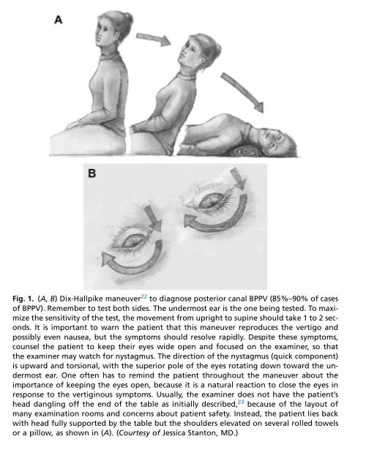

(b)

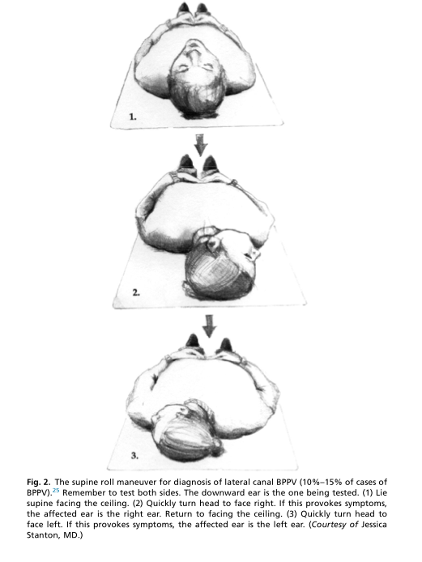

(c)

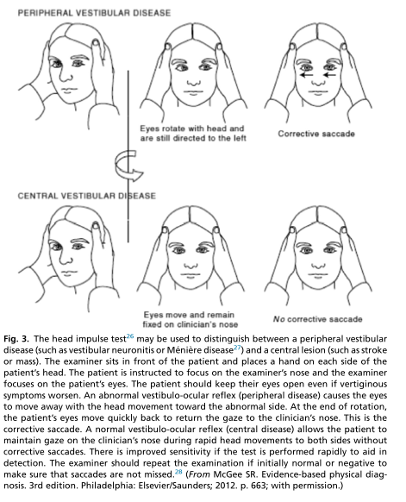

(d)
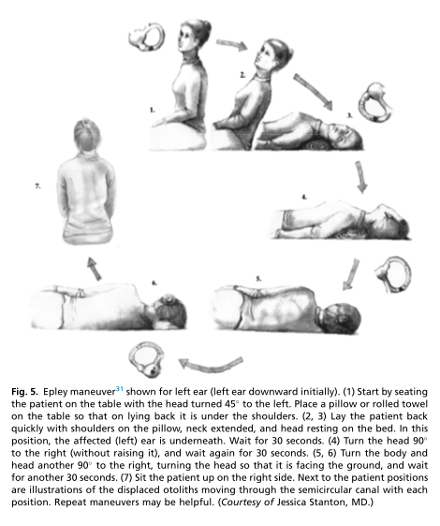
Reference:
Molnar, A. and McGee, S. (2014). “Diagnosing and Treating Dizziness.” Medical Clinics of North America. 98:583-596.

