20. Upper Respiratory Infections By Andy Coyle

Overview
- Main role is TRIAGE: Differentiating bacterial syndromes (Strep pharyngitis, Pneumonia, Sinusitis) vs. Influenza vs. “Viral URI” (“the common cold”)
- Illness Scripts for common items in differential:
  - Strep Pharyngitis: Fever, pain worst near onset of symptoms, lack of cough. On exam, tonsillar erythema/exudates and tender anterior cervical lymphadenopathy
  - Bacterial Pneumonia: Fever, productive cough. Abnormal pulmonary examination.
  - Bacterial Sinusitis: Fevers, sinus pain/pressure, purulent nasal discharge
  - Allergies: History of similar symptoms in preceding years, history of atopy or other allergies, watery nasal discharge with post-nasal drip Cough.
Non-Influenza Viral Upper Respiratory Infection (= Viral URI = Common Cold)
- > 200 viruses can cause the common cold
- Symptoms: sore throat, cough, mild fatigue, runny nose with clear nasal discharge. Fevers are unusual. Examination is typically normal or with minimal abnormalities.
- Management: Nearly all therapies for viral URIs have limited efficacy and evidence, so goal is often to target most bothersome symptoms with 1-2 medications. By symptom, options include:
  - PAIN: Acetaminophen, NSAIDs
  - RUNNY NOSE: Antihistamines, Nasal Saline, Intranasal Ipratropium, Decongestants (pseudoephedrine, phenylephrine)
  - COUGH: Robitussin (Dextromethorphan-Guaifenesin), Benzonatate(Tessalon),
- Other therapies have generally not proven effective. Vitamin C does not reduce duration of symptoms. Zinc has some benefit in reducing duration of symptoms but has been associated with anosmia (especially the intranasal formulation) so is often avoided.

Influenza
- Influenza: Fever, productive cough, myalgias, significant fatigue.
- TESTING FOR INFLUENZA:
  - During influenza season, testing should be obtained for patients who have consistent symptoms and are: 1) Immunocompetent patients at high-risk for influenza complications (e.g. significant COPD, unstable CAD), 2) Immunocompromised patients, OR 3) Hospitalized patients
  - OF NOTE, immunocompetent patients who are not at high risk for complications DO NOT NEED TO BE TESTED. Decisions re: management should be made based on clinical judgement alone. This is because the rapid test has limited sensitivity and viral culture is too slow to impact antiviral medication decisions.
- Management
  - Supportive care and therapies as for other viral URIs (as above)
- LOW-RISK patients who present within 48 hours of symptom onset with strongly suggestive symptoms can be treated with oseltamivir (Tamiflu) to reduce symptom duration. Oseltamivir 75mg BID x 5 days is standard.
- HIGH-RISK patients are generally tested for influenza. IF test is + OR if your pre-test probability of influenza is very high, would treat with Oseltamivir (75 mg BID x 5 days) regardless of symptom onset (e.g. even if > 48 hours after onset).

VIRAL URI / INFLUENZA AT IMA
Relatively rare that we need to swab for Influenza in IMA (generally will choose to treat or not based on symptom duration and severity), but each room has 3 different types of swabs:
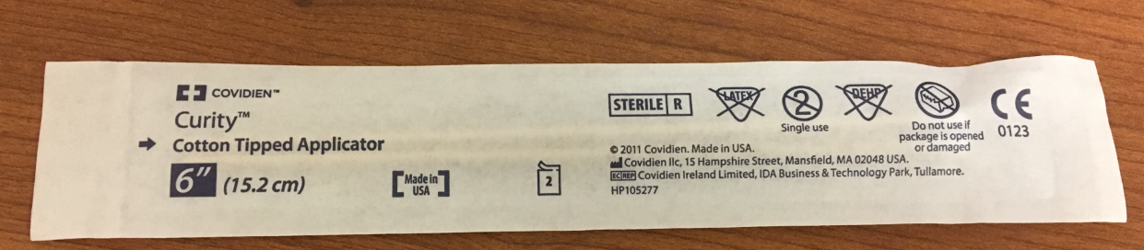
The “Cotton Tipped Applicator” are the general swabs and not used for anything sent out. You can use these to do rapid strep testing but that’s basically it.
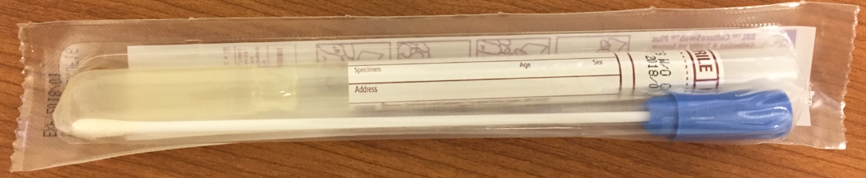
These blue top swabs are the culture swabs that are sent to the lab for anything bacterial. We use these for Gonorrhea/Chlamydia (on speculum exams), wound cultures, etc. You might use these for a Respiratory Infection if testing for a non-strep bacterial pharyngitis (such as gonoccocal pharyngitis) or you were extremely suspicious for strep pharyngitis but had a negative rapid test (and thus want to send formal culture).
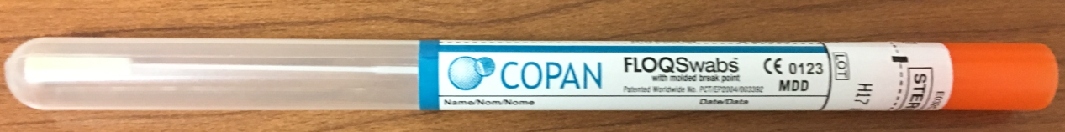
The last swab in the drawer will be the viral culture swab used for influenza. They seem to look different every year, but you can tell them apart as they are flexible (you’d have a hard time getting the stiff culture swab down someone’s nose to the nasopharynx!).

Population health/Systems-based practice:
- All patients should be offered vaccinations. The vaccine becomes available at IMA in early September and is given through the end of Influenza season (mid-to-late spring depending on CDC guidance).
- If patients decline, mark it DECLINED in the health maintenance sectionit’s one of the only metrics that you get credit for just asking – either giving the vaccine or noting that the patient declined will get you credit for you influenza vaccination percentage on the care gap reports!

