3. Obesity & Clinical Nutrition By Danny Mays

Overview:
- Weight is all about energy balance: resting energy expenditure (organ and muscle function) + additional expenditure from physical activity.
  - Weight gain: 5% energy mismatch (intake>expenditure) for 1 year = 15kg weight gain.
  - Weight loss: energy balance must be net negative. Goal deficit ~3500 calories/week ≈ 1 lb body fat, achieve through calorie restriction (more vegetables, whole grains) and increased physical activity.
  - Muscle is highly metabolically active, even at rest, so add strength training to maintain healthy weight.
- BMI:
  - “Normal” weight 18.5-20
  - Overweight 25-30
  - Obese 30+ (class I 30-35, II 35-40, III 40+)
    - These cutoffs are somewhat arbitrary, don’t account for things like muscle mass and don’t apply to all populations equally, e.g. a healthy maximum BMI for Asians tends closer to 20. But we use to this to approximate disease risk.
- Nutrition essentials:
  - The type of fat (unsaturated, fish oils) is more important than total fat.
  - Fruit/vegetables (~5 servings daily) associated with decreased risk of CVD, breast cancer, mortality.
  - Limit refined carbs/sugar (↑CHD and DM risk).
  - High salt intake linked with HTN, CVD…increases intravascular volumeincreasing afterload and ultimately long-term vascular remodeling.
  - Food labels: ingredients are listed by weight. Avoid food with sugar in the first 3 ingredients.

Obesity at IMA
- Cannot fix at 1 visit! Must build rapport and bring the patient back often to monitor progress
- Initial assessment can be a 24-hr diet recall or the 3-day food diary.
- Assess how food is obtained and prepared.
- Assess cultural norms and time/financial constraints.
- Assess the stage of change and ask “what do you think you can do to improve your diet?”
- Set attainable goals
- No compelling evidence for one diet vs. another (low fat, low carb, etc.).
- Goal = energy deficit through healthy eating and regular exercise.
- Referral to “IMA Nutrition” and can make an appointment at the front desk.

Population Health
- Nationwide, 71% overweight and 38% obese.
- In recent decades, large increases in obesity with parallel increases in diabetes, CVD
- Disproportionately high obesity prevalence in populations of color, notably Black and Hispanic.
- Disproportionately high obesity prevalence in Harlem and the Bronx, where most IMA patients live.
- Population health impact of healthy lifestyle change: Huge, better than putting all pre-diabetics on metformin (Diabetes Prevention Program, NEJM 2002).
- Sustained weight loss of 3-5% body weight produces clinically meaningful reductions in CV risk factors. Recommend 5-10% weight loss as initial 6-month goal for greater benefits.

Socioeconomic barriers to healthy nutrition:
- Poor availability of healthy foods, high availability of unhealthy foods. Poverty, lack of safe green space, and stress (↑cortisolglycemia)

Community Resources:
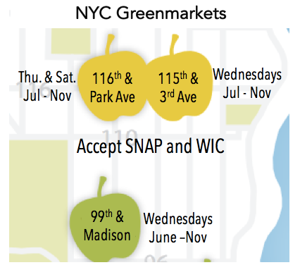
Nutrition resources: SNAP (food purchasing assistance for low income people, ~$125/month), WIC (supplemental nutrition program for Women, Infants, and Children).

City Health Works: Health coaching for diabetics with A1c > 8 in Manhattan. Referral forms in the preceptor rooms.

YMCA Diabetes Prevention: For patients overweight with pre-diabetic range A1c. Epic dotphrase to refer patients: .diabetesprevention (type in patient instructions in the wrap-up tab).

