Hypothyroidism By Ilana Ramer Bass
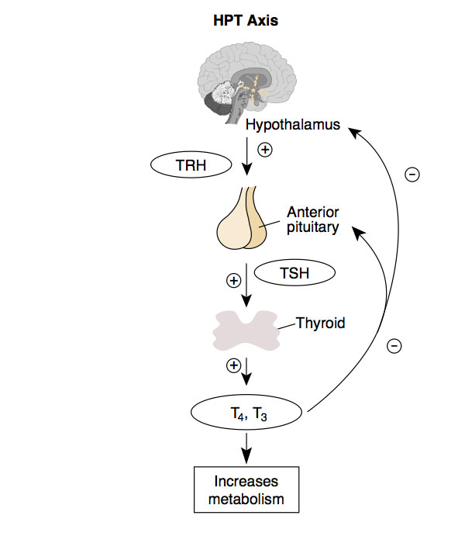
Overview:

Types of Hypothyroidism:
(a) Primary hypothyroidism (problem in the gland itself): low T3/T4, high TSH
- Accounts for 95% of cases of hypothyroidism
- Causes: autoimmune thyroiditis, Hashimoto's, previous Graves/de Quervains or painless thyroiditis, Down' syndrome, Turner's syndrome, previous thyroidectomy or other neck surgery, previous iodine therapy, external radiation

(b) Subclinical hypothyroidism: high TSH but normal T3/T4

(c) Secondary/Tertiary/Central hypothyroidism (problem in the pituitary/hypothalamus glands): low T3/T4 and low/inappropriately normal TSH
- Causes: hypothalamic or suprasellar mass, history of radiotherapy/surgery to the brain, infiltrative disease (sarcoid, hemochromatosis); pituitary tumor, hx of pituitary surgery/radiotherapy, Sheehan's syndrome

Pathophysiology/Clinical Signs/Symptoms:
- Generalized slowing of metabolic processes
  - fatigue, weakness, cold intolerance, weight gain, constipation
- Accumulation of matrix substances
  - coarse hair/skin, loss of lateral eyebrows, periorbital edema, carpal tunnel syndrome
- TRH increases prolactin levels which inhibit GnRH
  - oligo or amenorrhea, infertility
- Exam findings:
  - Delayed relaxation of DTRs, bradycardia, non-pitting edema, goiter
- Lab abnormalities:
  - Normocytic anemia, hypercholesterolemia, hyponatremia (SIADH), hyperprolactinemia, CK elevation

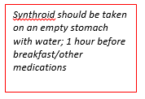
Treatment:
- Thyroid replacement therapy: levothyroxine/synthroid
  - Initial dose: 1.6 mcg/kg body weight per day (112 mcg/day in a 70-kg adult)
  - Re-check TSH in 6-8 weeks (takes 6 weeks to reach steady state) if TSH still elevated, increase by 12-25mcg/day and then re-check TSH in another 6 weeks
  - Goal TSH 0.5-5.0 mU/L
- Special situations:
  - Elderly patients >50-60 years old: initial dose 50mcg/day
  - History of CAD: initial dose 25mcg/day
  - Pregnancy: increased T4 requirements due to increased TBG
  - Poorly compliant patients: may give their weekly dose of T4 once per week
    - J Clin Endocrinol Metab 1997—achieve euthyroidism and no difference in symptoms between daily or weekly dosing

Treating Hypothyroidism at IMA:
- Order: "TSH with reflex T4"
- Who to test?
  - NO population-based screening for hypothyroidism
  - Only test if patient is symptomatic or if asymptomatic but at risk:
    - History of goiter, history of autoimmune disease, family history of thyroid disease, previous radioactive iodine therapy, and/or head and neck irradiation, family history of thyroid disease; on medications such as lithium, amiodarone
- Endocrine E-Consult
  - Allows you to submit clinical questions to Sinai endocrinologists and get timely responses/ recommendations
  - Order: “E-consult” and complete the referral template in the comment box

“The American Thyroid Association (ATA) and the American Association of Clinical Endocrinologists (AACE) recommend measurement of TSH in any individual at risk for hypothyroidism (eg, personal history of type 1 diabetes or other autoimmune disease, family history of thyroid disease, history of neck radiation to the thyroid, history of thyroid surgery) and consideration of measurement of TSH in patients over the age of 60 years”

