1. Health Care Maintenance By Brittney Zimmerman

Overview:
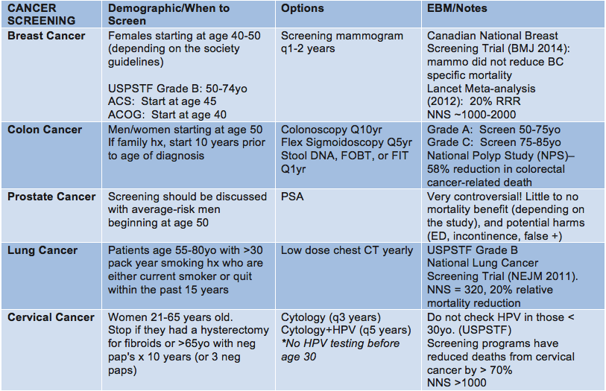

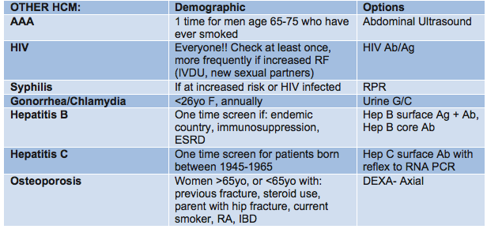

Options at IMA:
Breast Cancer:
- Order: “screening mammogram”
- CAM Radiology is on the 6th Floor on the East Side. When you order a mammogram, order requisition will print with location/phone # so patients can either:
  - Walk down immediately after visit to get mammogram (often done within an hour) or can walk-in at another time
  - Can call 212-824-7700

Colon Cancer:
- Colonoscopy
  - Order: “screening colonoscopy,” fill out patient information, GI consult if patient is on blood thinners or had previous abnormal scope
  - E-prescribe 1 day prep: Miralax powder 238g (17 packets)
  - Endoscopy scheduler should call the patient to review the prep and schedule the c-scope
  - Patients can call 212-659-8770 to follow up
- FIT test
  - Give VERBAL order to your MA to give patient FIT card before they leave the clinic
  - Patient needs to return card to IMA
  - Once you get results, make sure to update Health Maintenance section and Edit Modifier to "1 year" intervals

Prostate Cancer
- Order: “PSA” after careful discussion of risks/benefits with patient

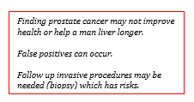

Lung Cancer
- Order: “Low dose CT chest”
- Email for prior authorization # IMA Radiology Cardiology Prior Approval Orders (search “CT scan” on the IMA app)

Cervical Cancer Screening
- Order: “cytology” w/ HPV co-testing if >30 years old.
- Options:
  - 1. Do pap yourself during visit need chaperone & get supplies in cart in Area D.
  - 2. Refer to IMA GYN order: “consult to Well Women’s Clinic”
  - 3. Refer to GYN clinic (OB/GYN staffed) order: “consult to gynecology”

AAA Screen:
- Order: “US Doppler Aorta and Iliac Arteries (Vascular Lab)” ICD 441.4 in EPIC
  - Make sure to write the indication “AAA screen”
  - Ask patient to schedule appointment by calling 212-731-6906

HIV:
- Order: “HIV Ab/Ag”
  - Make sure to document verbal consent in your note
- If very high risk or concerned, can have RN do swab testing however there are false positives
- If positive, refer to Jack Martin Fund Clinic for treatment.

Hepatitis B:
- Order: "Hep B surface Ag + Ab, Hep B core Ab"

Hepatitis C:
- Order: "Hep C surface Ab with reflex to RNA PCR"
- If positive, can refer to IMA Liver; however if decompensated cirrhosis, then refer to Liver Medicine

DEXA:
- Order: “DEXA- Axial Skeleton”
- Patients can call 212-241-3247, Radiology Associated 1176 5th Ave MC level
