14. Depression By Ilana Ramer Bass

Overview
Screening:
- PHQ-2 for every patient once a year
  - (1) During the last month, have you often been bothered by feeling down, depressed or hopeless? (yes/no)
  - (2) During the last month, have you often been bothered by having little interest or pleasure in doing things? (yes/no)
Diagnosis:
- Administer the PHQ-9 if screen positive with PHQ-2
  - Both 89% sensitive and 78% specific
  - Consider a depressive disorder if score >5
  - Major Depressive Disorder—5 out of 9 for > 2 weeks; must include question #1 or #2
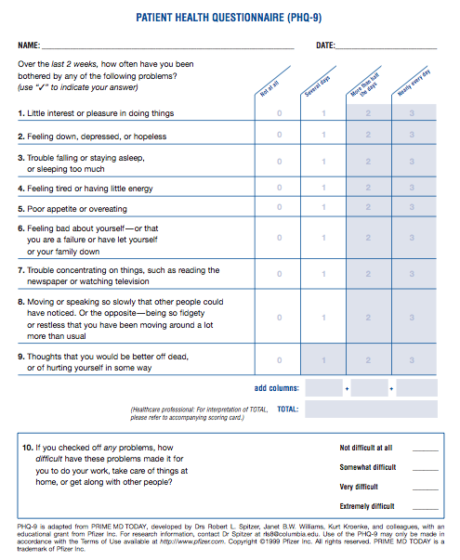

- Also must consider:
  - Bipolar disease, substance abuse, seasonal affective disorder, adjustment disorder, borderline personality, bereavement, post-partum depression
  - Medications (steroids, beta blockers, interferon), dementia, hypothyroidism, pancreatic cancer, Parkinson’s disease, hypercalcemia

Treatment:
- Psychotherapy vs. pharmacotherapy

“+” signifies that, on average, the medication is more likely to cause the given side-effect

Medication | Usual dose range | Drowsy/  sedating | Insomnia/  activating | Weight gain | Sexual side effects | GI upset | P-450 inhibition | Notes

SSRIs
escitalopram  Lexapro | 10-20mg qd | 0 | 1+ | 1+ | 1+ | 1+ | 1+ | Tolerated Efficacy
sertraline  Zoloft | 50-200mg qd | 0 | 2+ | 1+ | 2+ | 2+ | 1+ | Tolerated Efficacy
fluoxetine  Prozac | 20-80mg qd | 0 | 2+ | 0 | 2+ | 3+ | 2+ | Wt neutral, no w/drawal
citalopram  Celexa> | 10-40mg qd | 0 | 1+ | 1+ | 1+ | 1+ | 1+ | QT:ECG Monitor
paroxetine  Paxil | 20-60mg qd | 2+ | 1+ | 1+ | 3+ | 2+ | 2+ | SE ++, + w/drawal
SNRIs
venlafaxine  Effexor XR† | 75-375mg qd | 0 | 2+ | 0 | 1+ | 2+ | 1+ | Tx hot flash, w/drawal
duloxetine  Cymbalta‡ | 30-60mg bid | 0 | 2+ | 0 | 1+ | 2+ | 2+ | Tx pain fibromyalgia, np
DNRI
bupropion  Wellbutrin XL§ | 150-450mg qd | 0 | 2+ | -1∫ | 0 | 1+ | 1+ | -Smoking +seizuresmild wt loss
NSSA
mirtazepine  Remeron | 15-45mg qhs | 4+ | 0 | 3+ | 0/1+ | 0 | 0/1+ | Sleep and eat
> may prolong QT – max dose 40mg – check ECG prior to start and upon each titration.
† may raise blood pressure
‡indicated for chronic pain
§lowers seizure threshold
paradoxical effect of increased sedation at lower doses
∫ bupropion is associated with mild weight loss, on average

AT IMA
- PHQ-2 is administered by the MA before the encounter if positive, administer the PHQ-9 form
  - Calculate the score and enter it into Epic by going to “flowsheets” search “PHQ-9” and enter their score for each question (0-3) press “file” to save
  - Sometimes the patient screens positive but does not get the PHQ-9 form; in that case, you will see a BPA notification to proceed to PHQ-9
- Options for mental health referral—there are many options and this is always changing so confirm referral pathways using the IMA app**
  - (1) IMA Eval—consult “IMA Mental Health Evaluation”
    - Wednesday mornings; 2nd year residents precepted by Dr. Small and Dr. Peccoralo
    - For further evaluation and medical management of patients with depression and anxiety
  - (2) Depression Care Program: consult “IMA behavioral health”
    - Short term (~6 month) talk therapy with SWs Samantha Herrera and Lizbeth Valencia
    - Must have PHQ-9 >9 and Medicaid insurance
  - (3) IMA psych
    - For patients with bipolar disorder, personality disorder, ADD/ADHD, OCD, refractory or severe depression, PTSD, severe anxiety with functional impairment, SI/HI
  - (4) External referral
    - IMA SW Triage can assists with identifying resources and making appointments
  - (5) If active SI/HI, consider sending patient to psych ED—follow directions in the app
Social Determinants of Health:
- Risk factors for depression:
  - Single/divorced, substance use, lack of support system, adverse childhood experiences/trauma, chronic illnesses, high frequency utilizers
- Risk factors for suicide:
  - Isolation, substance abuse, new diagnosis, old white men, young adults, weapon owners, socioeconomic status, unemployment, history of psychiatric illness
- Protective factors:
  - Social support, religion/faith, caregiver role, forward-thinking

Community Resources: see app for further details
- Institute for Family Health – 212-423-4200 can do long-term counseling
- Union Settlement – 212-828-6144
- Metropolitan Hospital – 212-423-6645 fastest way to get psychiatric evaluation but can be hard to get information/records from them

Population Health
- Depression is the most common psychiatric disorder and the most common mental health condition among patients seen in primary care.
- Screening is important because depression can be difficult to detect; untreated depression is associated with decreased quality of life, increased mortality and increased economic burden.

