9. Anorectal Complaints/Constipation By Casey Sanossian

Overview:
(a) Constipation
- Risk factors: advanced age, physical inactivity, low income and education status, depression
- Rome III Constipation definition:
  - 1-2+ of following for 12 weeks in 6 month period:
    - Straining during >=25% defecations
    - Lumpy or hard stools >=25% defecations
    - Sensation of incomplete evacuation >=25% of time
    - Manual maneuvers to facilitate defecation of >=25% of time
    - <3 defecations/week
    - Loose stools rarely present w/o laxative
    - Insufficient criteria for IBS
- Causes include:
  - Normal transit/functional constipation, slow transit (medications, hypothyroidism, hypercalcemia, spinal cord disease), outlet obstruction (rectal mass, pelvic floor dysfunction), lifestyle (low fluid/fiber intake), eating disorders
- Treatment:
  - Address underlying cause if one exists
  - Drink at least 2L/water/day
  - Recommend 20-35 g fiber/day
  - Encourage regular exercise
  - If needed, use fiber supplements/bulk-forming laxatives osmotic laxatives stimulants and stool softeners (see below)
  - If refractory, biofeedback (effective to re-train muscles used in defecation if pelvic floor dysfunction) or surgery (abdominal colectomy + ileorectal anastomosis)

 | Medication | Mechanism of Action
Fiber supplements/Bulk forming agents | Methylcellulose (Citrucel)  Polycarbophil (FiberCon)  Psyllium (Metamucil) | Absorb liquid in the intestines to form bulky stools
Osmotic laxatives | Milk of magnesia  Lactulose  Polyethylene glycol (Miralax) | Pulls water into the intestinal lumen
Stimulant laxatives | Senna (senokot)  Bisacodyl (dulcolax) | Stimulate colonic contractions to propel stool forward
Stool softeners | Docusate sodium (Colace) | Soften stool to make it easier to pass
Newer medications | Lubiprostone  Linactolide | Stimulate chloride and water secretion into the intestinal lumen

(b) Hemorrhoids
- Symptoms: itching, pain, bleeding; ~75% of patients will have at some point in their life!
- Types:
  - External: painful 2/2 innervation by somatic nerves
  - Internal: generally present as painless rectal bleeding because covered by insensate columnar epithelium
- Treatment:
  - Anesthetics
  - Astringents and protectants witch hazel, zinc oxide
  - Bulk-forming laxatives
  - Topical corticosteroids (Preparation H)
  - Stool softeners
  - If more severe: external (surgical excision); internal (band ligation, radiofrequency treatment

(c) Pruritis Ani
- Symptoms: itch or burn in perianal area
- Etiology: usually idiopathic or due to “ITCH:” Infection, Topical irritants, Cutaneous/Cancer, Hypersensitivity
- Treatment:
  - Keep stools soft, stop itching and/or excessive cleansing, sitz baths (4X/d), avoid tight clothing/moisture trapping fabrics, witch hazel pads (topical anti-pruritic), topical hydrocortisone (max 1-2 weeks otherwise risk skin atrophy), antihistamines (atarax for symptom relief)
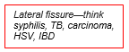
(d) Anal Fissure- tears occurring distal to dentate line in anal canal
- Etiology: usually due to hard BMs/straining
  - Usually ANTERIOR or POSTERIOR to ANUS
- Treatment:
  - Keep stools soft, sitz baths, rectal suppository (containing topical steroids, local anesthetics), topical lidocaine, NTG ointment or topical CCB (relaxes internal anal sphincter)

(e) Rectal Bleeding
- Causes of bright red blood:
  - Hemorrhoids, diverticula, UC, infectious colitis, cancer, polyps, AVM, fistula, fissure, chronic solitary ulcer
- Causes of occult bleeding:
  - Gastritis, gastric ulcer, gastric CA, esophageal varices, AVM, esophagitis, duodenitis, duodenal ulcer, polyps, cancer

(f) Condyloma acuminatum
- Etiology: HPV
  - Once infected with HPV, entire anogenital tract is involved!
  - If one lesion present complete anogenital exam to detect additional growths
- Higher risk if anal intercourse, but majority of patients with perianal condylomata have NOT engaged in anal intercourse!
- HPV infection also increases risk of anal cancers high risk patients need annual anal pap smears

(g) Fistula
- Most common cause = infection of anal glands
- High index of suspicion for Crohn’s Disease

(h) Skin tags
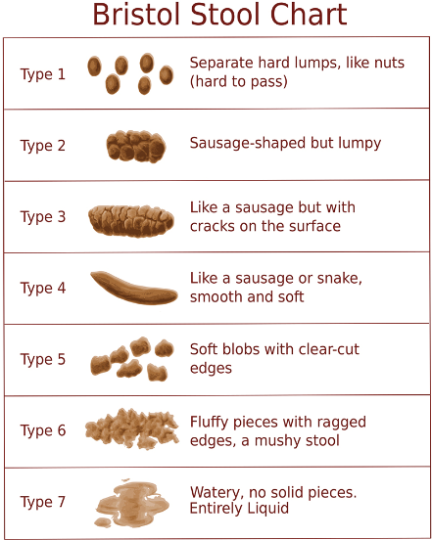
- Usually asymptomatic, remnants of previously thrombosed external hemorrhoids (removed only if symptomatic)

At IMA:
- History—ask patients about:
  - BM frequency, consistency, any change in stools, fluid intake, diet, opioid use
- Evaluate for tenderness, skin breakdown, fistulae, fissures, masses on exam
- Labs: CBC, TSH, BMP
- Consider colonoscopy in patients with alarm symptoms or age >50
- Diet/exercise counseling!

Social determinants of health:
- Many patients are uncomfortable discussing this topic, but be sure to ask about it in your ROS!
- Major sources of dietary fiber include fruits and vegetables which may not be as available (physically- and financially-speaking) – look into whether patients would qualify for SNAP; discuss farmer’s markets and other creative ways of increasing their intake of fruits/vegetables/whole grains

