6. Cardiac Symptom Evaluation By Andrew Bromley

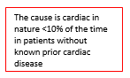
(a) Palpitations
Overview
- Common ambulatory complaint
- Symptom timing and cardiac causes:
  - Transient palpitations often due to premature beats
  - Slow onset and offset more consistent with sinus tachycardia
  - Rapid onset and termination may suggest SVT or VT
- Differential to consider in work-up of palpitations:
  - Cardiac: arrhythmias, valvular heart disease, atrial myxoma, cardiomyopathy
  - Endocrine/Metabolic: thyrotoxicosis, hypoglycemia, pheochromocytoma
  - Medications: nicotine, caffeine, cocaine, amphetamines, sympathomimetic agents, vasodilators (e.g. CCBs), anticholinergic medications, BB withdrawal
  - Psych: panic disorder, GAD, depression w/ anxiety, somatization
  - Other: anemia, pregnancy, high fevers, stress

At IMA:
- Work-up:
  - 12-lead ECG
  - Lab work: CBC, TSH, BMP
  - Imaging: TTE in pts w/ signs/sxs/risk for structural heart disease
  - Ambulatory EKG monitoring: may be necessary in pts whose evaluation suggests an arrhythmia, those at higher risk (male gender, event duration >5 mins, irregular rhythm, hx of cardiac disease)
    - Holter Monitor (Ambulatory EKG)
    - Event Monitor
    - Loop Recorder
- How to order ambulatory EKG monitoring:
  - Pt must be seen by a Mount Sinai Cardiologist. Therefore…
    - Pt has a Mount Sinai Cardiologist: order “Holter Monitor”
    - Pt does not have Mount Sinai Cardiologist: order “consult to cardiology.” Pt can call (212) 427-1540 to schedule appointment.

(b) Chest Pain Evaluation
Overview:
- Differential Diagnosis:
  - MSK: costochondritis, muscle strain
  - CV: CAD, coronary vasospasm, pericarditis, Dissection
  - GI: GERD, Achalasia, DES, Esophagitis
  - Pulm: PE, Lung Cancer, Pneumonia, Pneumothorax, Pleuritis
  - Other: Anxiety, Zoster
- Defining chest pain:
  - 1) substernal chest discomfort of characteristic quality (i.e., pressure, heaviness) and duration (seconds to minutes, not hours to days) 2) exacerbated by exertion and 3) relieved by rest or SL nitroglycerin
    - Typical: fits all three characteristics
    - Atypical: two of the characteristics
    - Non-anginal or non-cardiac chest pain: only one of the characteristics or none
- Risk Stratification: by type of chest pain, age, and gender
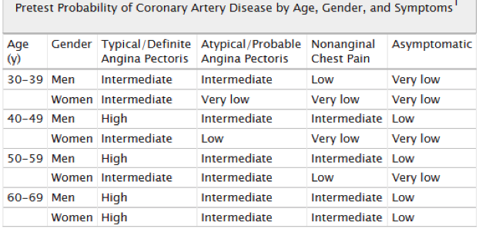

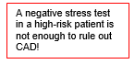
- Management:
  - Low risk no intervention
  - Intermediate risk
    - Ideal candidate for a stress test
    - To determine what type of stress test to order, see below
  - High risk
    - Refer to cardiology for catheterization

Stress Testing
- There are multiple modalities at our disposal for the evaluation of CAD
- Determining the need for stress test must take into account the pre-test probability that the patient's chest pain is related to CAD:
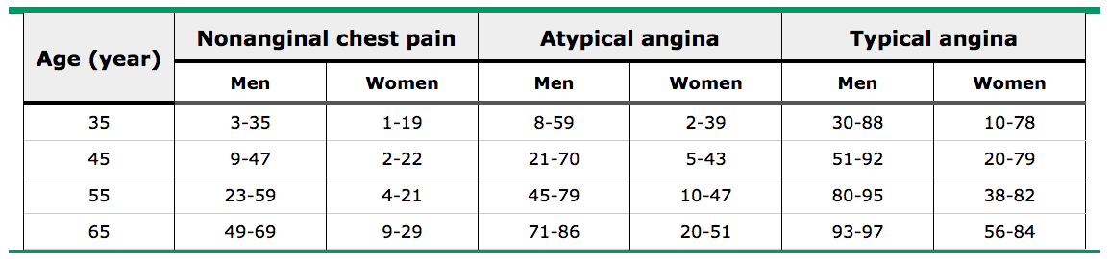

  - 1st: Determine the type of chest pain your patient is having (see above)
  - 2nd” Determine whether your patient falls into a low, intermediate, or high-risk group
    - Stress test is most appropriate and of highest yield for patients with intermediate-risk
    - Before considering a stress test for your patient, be sure that you would want to pursue the further workup involved with a positive stress test. Would you and your patient pursue a left-heart catheterization? If the answer is no, consider whether it is then worthwhile to even get a stress test.

Types of Stress Tests:
 | ECG | Echo | Nuclear
Exercise | Sens: 68%  Spec: 77% | Sens: 86%  Spec: 81% | Sens: 87%  Spec: 73%
Pharmacologic | Not an option | Dobutamine | Adenosine or  Dipyridamole
What is studied | ST-segment changes, T wave inversions, or arrhythmias w/ exercise | Regional wall motion abnormalities | Myocardial perfusion and viability
Pro | Simple, inexpensive, well-validated.  Physiologic.  Assesses exercise capacity.  No need for IV access or radiation | Well-validated  No radiation exposure  Can be exercise or pharmacologic  Shows myocardial function and regional wall motion abnormalities | Most sensitive  Provides anatomic details and LV function  Provides prognostic information  Provides assessment of myocardial viability
Con | Less sensitive (especially in women)  Requires good exercise tolerance  Cannot be used in pts w/ pre-existing ECG abnormalities: 1) underlying BBB 2) ST-segment depressions 3) on Digoxin 4) repolarization abnormalities 5) WPW | Hypertensive response to stress may result in FPs (reversible wall motion abnormalities)  Very obese pts may have poor windows for echo | Expensive  Radiation exposure  Slow  More prone to artifact  Adenosine must be avoided in asthma pts

- Thinking through which stress test to order for your patient?
  - 1) Can the patient exercise?
    - Yes:
      - 2) Are there underlying ECG abnormalities?
        - No → Exercise ECG
        - Yes:
          - 3) Wall motion abnormalities?
            - No → Exercise ECHO
            - Yes → MPI
    - No:
      - 3) Wall motion abnormalities?
        - No → Pharmacologic stress ECHO
        - Yes → MPI

At IMA:
- Tests that we can order from IMA:
  - Exercise stress test
  - Myocardial perfusion stress test
  - Dobutamine Stress test
- Once ordered, have your patient schedule the test by calling (855) 674-3278.
- For all other tests or complex decisions, consider referring your patient to cardiology: “Consult to Cardiology” and patient can call (212) 427-1540 to schedule.
- If an expedited appointment is needed, you can email the schedulers listed in the IMA app under the “Cardiology” section

