18. Asthma By Ilana Ramer Bass
Overview:

Asthma= chronic inflammatory disorder of the airways characterized by bronchial hyper-responsiveness, or the tendency of airways to narrow excessively in response to a variety of stimuli
- Typically diagnosed at a young age (75% before age 7) but can develop at any age
- History— recurring, episodic symptoms of dyspnea, wheezing, cough and presence of triggers
  - Common triggers: exercise, cold air, allergens (pollen, trees, grass, weeds), pets, mites, molds, cockroaches, rodents, moisture/dampness
- Exam findings: wheezing; can also look for nasal polyps, skin changes consistent with atopic dermatitis

Evaluation:
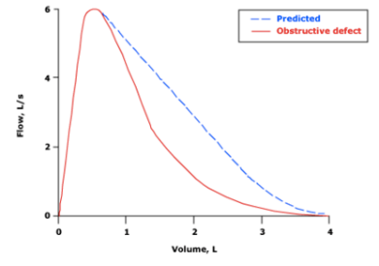
- History or presence of respiratory symptoms that are episodic + documented variable expiratory airflow obstruction
- Pulmonary Function Testing—used to:
  - Calculate FEV1/FVC ratio
    - Restrictive- normal ratio and FVC <80% predicted
    - Obstruction- reduced ratio (0.70) or scooped/concave appearance to expiratory portion of flow-volume loop
  - Assess reversibility of obstruction with administration of a bronchodilator
  - Characterize severity of obstruction (% of normal predicted value)
  - If normal baseline airflow, can use bronchoprovication testing (methacholine) to stimulate bronchoconstriction and prove hyperresponsiveness
- Determine Severity:
  - Intermittent= <2 days/week and <2x/month nighttime awakenings
    - Use SABA < 2 days/week
  - Persistent
    - Mild: >2 days/week but not daily and 3-4x/month nighttime awakenings
    - Moderate: daily symptoms and >1x/week nighttime awakenings but not nightly
    - Severe: throughout the day, nightly awakenings, need to use SABA several times/day
Management:
- 4 components:
  - Routine monitoring of symptoms and lung function
    - Monitor with peak expiratory flow (PEF)
  - Patient education
    - Must understand how to use inhalers properly!!
  - Controlling environmental triggers
  - Pharmacologic therapy
- Step Therapy:
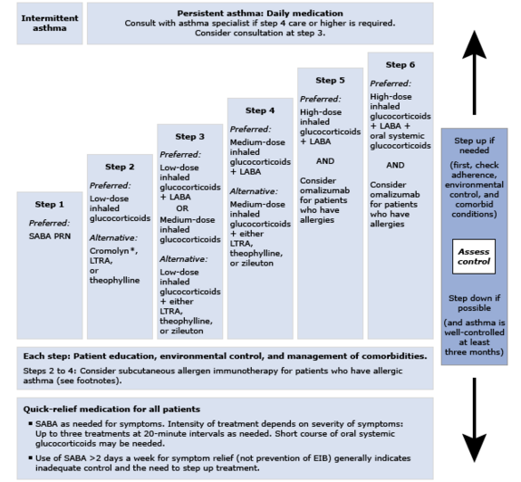

**SABA= albuterol
**ICS= beclomethasone, budesonide, flunisolide, fluticasone, triamcinolone acetonide, mometasone
**Combination ICS + LABA= advair (fluticasone/salmeterol) or symbicort (budesonide/fomoterol)
**LTRA= leukotriene receptor atagonists such as montelukast (singulair)

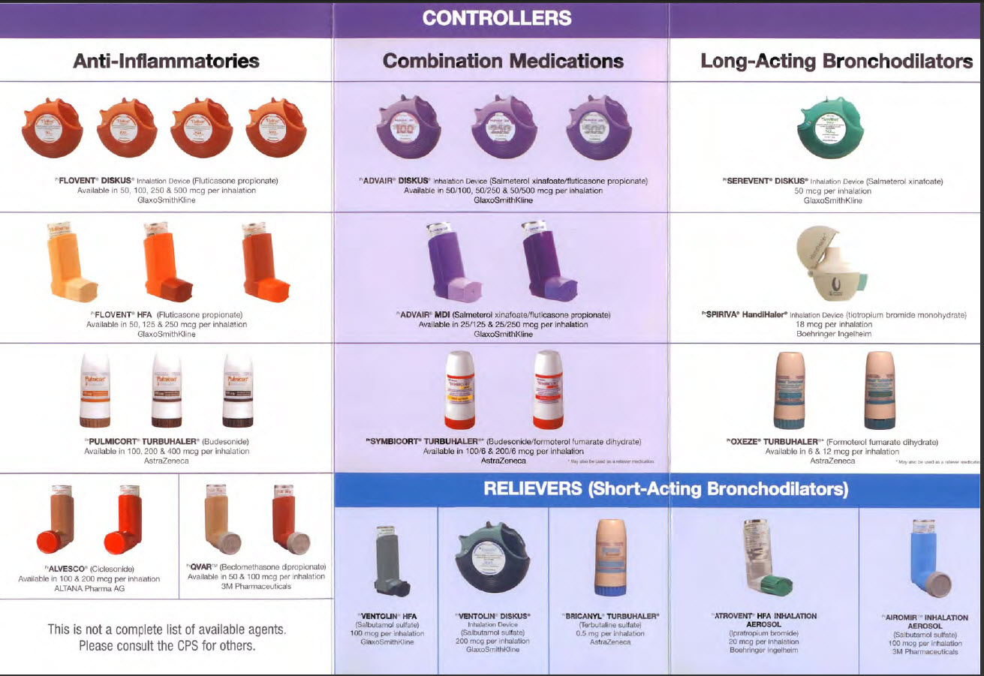

Asthma at IMA:
- Suspect asthma? Order: “Respiratory Flow Volume Loop” and insert smartphrase “.spirometry” in the comments section and direct patient to the MA
- If you need full PFTs, must order: “Pulmonary Function test” and specific which components (spriometry, lung volumes, DLCO, with/without bronchodilator) and provide patient with phone number to schedule
- When to refer:
  - Pulmonology if diagnosis is uncertain, asthma is difficult to control, or frequent exacerbations/hospitalizations
  - Allergy/Immunology if allergic triggers need further evaluation

Social Determinants of Health:
- Higher rates of asthma in low-income neighborhoods/public housing due to poor air quality
- East Harlem is ranked #1 in NYC for asthma ER visits for children (71.6 per 1,000 children)

