15. Anxiety By Ilana Ramer Bass

Overview:
- Generalized Anxiety Disorder (DSM-5):
  - Excessive anxiety and worry (apprehensive expectation), occurring more days than not for at least six months, about a number of events or activities (such as work or school performance)
  - The individual finds it difficult to control the worry.
  - The anxiety and worry are associated with three (or more) of the following six symptoms (with at least some symptoms having been present for more days than not for the past six months):
    - 1. Restlessness or feeling keyed up or on edge
    - 2. Being easily fatigued
    - 3. Difficulty concentrating or mind going blank
    - 4. Irritability
    - 5. Muscle tension
    - 6. Sleep disturbance (difficulty falling or staying asleep, or restless, unsatisfying sleep)
  - The anxiety, worry, or physical symptoms cause clinically significant distress or impairment in social, occupational, or other important areas of functioning.
  - The disturbance is not attributable to the physiological effects of a substance (eg, a drug of abuse, a medication) or another medical condition (eg, hyperthyroidism).
  - The disturbance is not better explained by another mental disorder
- Consider alternate vs. concurrent diagnosis:
  - Panic disorder—panic attacks characterized by episodes of intense anxiety, diaphoresis, dyspnea
  - Social phobia
  - Obsessive Compulsive Disorder
  - Post traumatic Stress Disorder
  - Depression
  - Hypochondriasis—worried principally about medically unexplained symptoms
- Risk factors:
  - Female sex, poverty, recent adverse life events, chronic physical illness, chronic mental disorder, parental loss or separation, low affective support during childhood, history of mental problems in parents

AT IMA
- Screen with GAD-7—positive score is >8 points
  - 5-9- mild
  - 10-14- moderate
  - 15-21- severe; treatment warranted
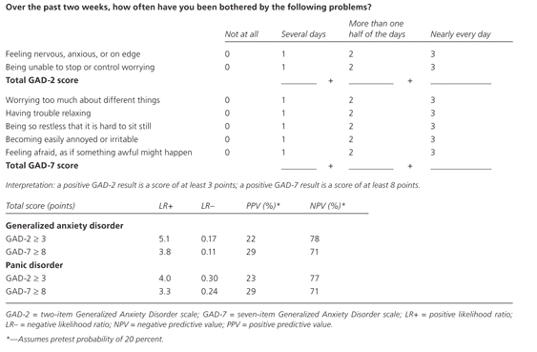

- History: ask about substance abuse, medical history, family history of psychiatric illness, social history (history of sexual/physical/emotional abuse); consider side effects from medications
- Labs to rule out organic causes: TSH, CBC, BMP, EKG or U.tox
- Treatment:
  - Cognitive-behavioral therapy
  - 1st line pharmacotherapy: SSRIs and SNRIs (see chart under section 14 Depression)
  - Other: buspirone, pregabalin
  - Benzodiazepines are effective however risk of dependence and tolerance
  - Referral to IMA Eval for further evaluation of anxiety or to optimize medications (ex: taper off benzos, up-titrate SSRI)

